PENNIES FOR PULLUPS 2022

What Is It?
Pennies for Pull-ups is the annual charity fundraiser of Farmgirlfit. Each year this is how Farmgirlfit celebrates their anniversary: a challenge for the members and an opportunity to give back to the local community that supports them year-round. This year is the 11th Anniversary!

How Does It Work?
Each day in October, Farmgirlfit members are challenged to complete the number of pull-ups corresponding to the date:
October 1st – do 1 pull-up
October 2nd – do 2 pull-ups
October 3rd – do 3 pull-ups, and so on, until
October 31st – do 31 pull-ups!

By the end of the month, if a member completes the FULL challenge, they will have done 496 pull-ups! There’s also a bonus option to complete 4 more on the last day to join the 500 Club.

For every pull-up completed during the month, Farmgirlfit will donate 1 penny ($0.01) to a local charity.

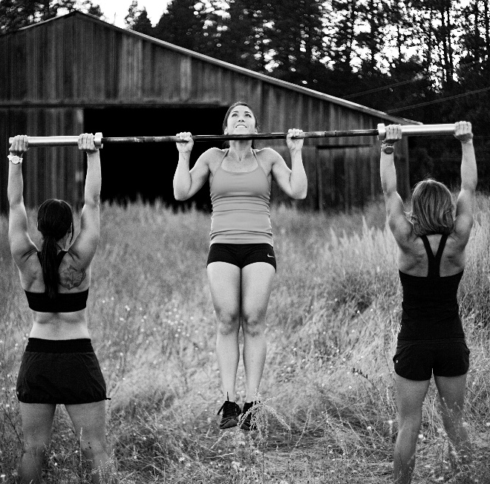

Who Benefits?
This year, 100% of the funds raised will be donated to Cancer Can’t.
Cancer Can’t is a non-profit organization started by a cancer patient. Their mission is to help people fighting cancer in the Inland Northwest by improving their daily lives and circumstances.

My Personal Goal is:
__________________________________________________________________________________________________________________________________________________________
Will YOU match Farmgirlfit’s pledge, by sponsoring me 1¢ for EVERY pull-up I complete in October?

Donation Collection
I will come collecting the first week of November. Payment can be made via Cash, Check (payable to Farmgirlfit OR to Cancer Can’t), or PayPal to info@farmgirlfit.com. For PayPal, please specify it for “Friends and Family.”

